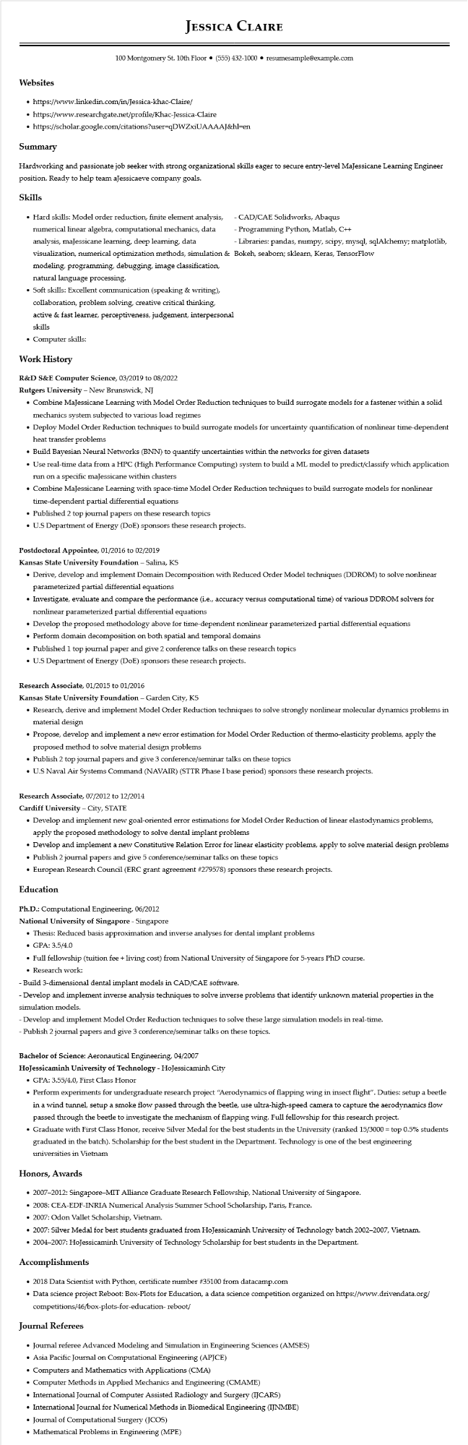
Websites
JESSICA CLAIRE
100 Montgomery St. 10th Floor⚫ (555) 432-1000⚫ resumesample@example.com
https://www.linkedin.com/in/Jessica-khac-Claire/
• https://www.researchgate.net/profile/Khac-Jessica-Claire
• https://scholar.google.com/citations?user=qDWZxiUAAAAJ&hl=en
Summary
Hardworking and passionate job seeker with strong organizational skills eager to secure entry-level MaJessicane Learning Engineer position. Ready to help team aJessicaeve company goals.
Skills
• Hard skills: Model order reduction, finite element analysis, numerical linear algebra, computational mechanics, data analysis, maJessicane learning, deep learning, data visualization, numerical optimization methods, simulation & modeling, programming, debugging, image classification, natural language processing.
• Soft skills: Excellent communication (speaking & writing), collaboration, problem solving, creative critical thinking,
active & fast learner, perceptiveness, judgement, interpersonal skills
• Computer skills:
Work History
R&D S&E Computer Science, 03/2019 to 08/2022
Rutgers University - New Brunswick, NJ
CAD/CAE Solidworks, Abaqus
Programming Python, Matlab, C++
- Libraries: pandas, numpy, scipy, mysql, sqlAlchemy; matplotlib, Bokeh, seaborn; sklearn, Keras, TensorFlow
• Combine MaJessicane Learning with Model Order Reduction techniques to build surrogate models for a fastener within a solid mechanics system subjected to various load regimes
• Deploy Model Order Reduction techniques to build surrogate models for uncertainty quantification of nonlinear time-dependent heat transfer problems
• Build Bayesian Neural Networks (BNN) to quantify uncertainties within the networks for given datasets
• Use real-time data from a HPC (High Performance Computing) system to build a ML model to predict/classify which application run on a specific maJessicane within clusters
• Combine MaJessicane Learning with space-time Model Order Reduction techniques to build surrogate models for nonlinear time-dependent partial differential equations
• Published 2 top journal papers on these research topics
• U.S Department of Energy (DOE) sponsors these research projects.
Postdoctoral Appointee, 01/2016 to 02/2019
Kansas State University Foundation - Salina, KS
• Derive, develop and implement Domain Decomposition with Reduced Order Model techniques (DDROM) to solve nonlinear parameterized partial differential equations
• Investigate, evaluate and compare the performance (i.e., accuracy versus computational time) of various DDROM solvers for nonlinear parameterized partial differential equations
• Develop the proposed methodology above for time-dependent nonlinear parameterized partial differential equations
• Perform domain decomposition on both spatial and temporal domains
• Published 1 top journal paper and give 2 conference talks on these research topics
• U.S Department of Energy (DOE) sponsors these research projects.
Research Associate, 01/2015 to 01/2016
Kansas State University Foundation - Garden City, KS
• Research, derive and implement Model Order Reduction techniques to solve strongly nonlinear molecular dynamics problems in material design
• Propose, develop and implement a new error estimation for Model Order Reduction of thermo-elasticity problems, apply the proposed method to solve material design problems
• Publish 2 top journal papers and give 3 conference/seminar talks on these topics
• U.S Naval Air Systems Command (NAVAIR) (STTR Phase I base period) sponsors these research projects.
Research Associate, 07/2012 to 12/2014
Cardiff University - City, STATE
• Develop and implement new goal-oriented error estimations for Model Order Reduction of linear elastodynamics problems, apply the proposed methodology to solve dental implant problems
• Develop and implement a new Constitutive Relation Error for linear elasticity problems, apply to solve material design problems
• Publish 2 journal papers and give 5 conference/seminar talks on these topics
• European Research Council (ERC grant agreement #279578) sponsors these research projects.
Education
Ph.D.: Computational Engineering, 06/2012
National University of Singapore - Singapore
• Thesis: Reduced basis approximation and inverse analyses for dental implant problems
• GPA: 3.5/4.0
• Full fellowship (tuition fee + living cost) from National University of Singapore for 5-years PhD course.
• Research work:
-Build 3-dimensional dental implant models in CAD/CAE software.
-Develop and implement inverse analysis techniques to solve inverse problems that identify unknown material properties in the simulation models.
-Develop and implement Model Order Reduction techniques to solve these large simulation models in real-time.
-Publish 2 journal papers and give 3 conference/seminar talks on these topics.
Bachelor of Science: Aeronautical Engineering, 04/2007
HoJessicaminh University of Technology - HoJessicaminh City
• GPA: 3.55/4.0, First Class Honor
• Perform experiments for undergraduate research project "Aerodynamics of flapping wing in insect flight". Duties: setup a beetle in a wind tunnel, setup a smoke flow passed through the beetle, use ultra-high-speed camera to capture the aerodynamics flow passed through the beetle to investigate the mechanism of flapping wing. Full fellowship for this research project.
• Graduate with First Class Honor, receive Silver Medal for the best students in the University (ranked 15/3000≈ top 0.5% students graduated in the batch). Scholarship for the best student in the Department. Technology is one of the best engineering universities in Vietnam
Honors, Awards
• 2007-2012: Singapore-MIT Alliance Graduate Research Fellowship, National University of Singapore.
• 2008: CEA-EDF-INRIA Numerical Analysis Summer School Scholarship, Paris, France.
• 2007: Odon Vallet Scholarship, Vietnam.
• 2007: Silver Medal for best students graduated from HoJessicaminh University of Technology batch 2002-2007, Vietnam.
• 2004-2007: HoJessicaminh University of Technology Scholarship for best students in the Department.
Accomplishments
⚫ 2018 Data Scientist with Python, certificate number #35100 from datacamp.com
• Data science project Reboot: Box-Plots for Education, a data science competition organized on https://www.drivendata.org/ competitions/46/box-plots-for-education- reboot/
Journal Referees
• Journal referee Advanced Modeling and Simulation in Engineering Sciences (AMSES)
• Asia Pacific Journal on Computational Engineering (APJCE)
• Computers and Mathematics with Applications (CMA)
• Computer Methods in Applied Mechanics and Engineering (CMAME)
• International Journal of Computer Assisted Radiology and Surgery (IJCARS)
• International Journal for Numerical Methods in Biomedical Engineering (IJNMBE)
• Journal of Computational Surgery (JCOS)
• Mathematical Problems in Engineering (MPE)

